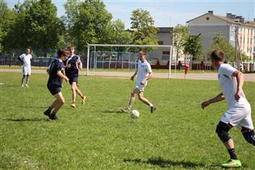
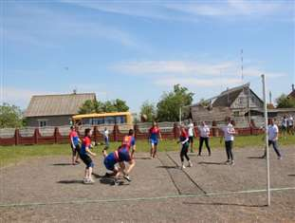
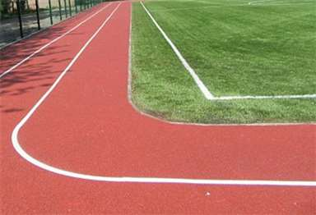
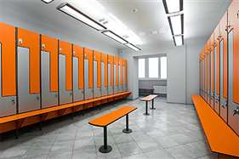
The Dokshitsy rigion
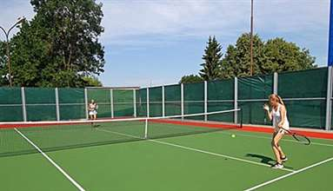
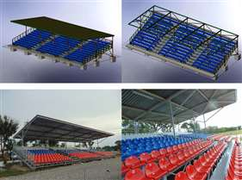
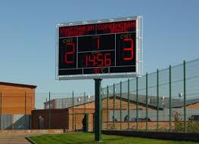
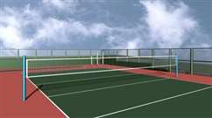
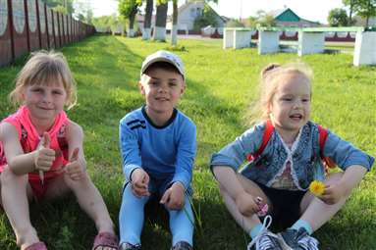

1. | Name of the  project | “Dokshitsy – SPORTS”. The improvement of an open surface – a football field in Dokshitsy
2. | Name of the organization | Sports and Tourism Sector of the Dokshitsy District Executive Committee
3. | Physical and legal address of the organization, phone, fax, e-mail | 211722, Shkolnaya st., 19, Dokshitsy, Vitebsk region, phone / fax 8 (02157) 2-52-31, fck_dok@mail.ru
4. | Information about the organization | The sector was created on June 1, 2018. It is a legal entity. It has a centralized accounting unit. The sector manages sports and tourism in the Dokshitsy district: the development of youth sports and mass physical culture, the preparation of high-class athletes and a sports reserve, the development of physical culture and sports movement and improvement of health of the district population. It promotes the creation and strengthening of sports ties with sports organizations on the territory of the Republic of Belarus and other states. Subordinate to the sector are: "Dokshitsy District Children and Youth Sports School" and the establishment "Dokshitsy District Physical Culture and Sports Club "Harvest". There is an experience in project activities in the relevant field
5. | Head of the  organization | Odintsova Tatsiana Nikolaevna, head of the sector, +375333060616 (MTS)
6. | Project manager | Rachitskaya Ekaterina Sergeyevna, sector inspector, +375295919989 (MTS)
7. | The assistance previously received from other foreign sources | "Dokshitskaya District Sport School" implemented local initiative “Keep Young People Healthy” in the amount of US $ 29,000 within the framework of the implementation of the international technical assistance project "Assistance to the development at the local level in the Republic of Belarus", which is funded by the European Union and implemented by the United Nations Development Program (UNDP) on the territory of Dokshitsy region in 2017-2018
8. | Amount required | 400 000 Euro
9. | Co-financing | Regional budget
10. | Time-frame | 24 months from the start of the project

11. | Project mission | The creation of conditions that provide an opportunity for the population to lead a healthy lifestyle, systematically engage in physical education and sports; the development of the infrastructure of physical culture and sports of Dokshitsy district in accordance with modern safety and comfort requirements; the improvement of physical culture, the health-improving and sports-mass work among the population
12. | Objectives | 1. To organize healthy leisure time and the opportunity to lead an active lifestyle  2. To promote health improvement of children, the identification of their physical potential  3. The formation of life norms that contribute to the preservation and strengthening of health, the development of stereotypes of a healthy lifestyle to effectively counter the unfavorable factors of the social environment of children and adolescents, working youth, disabled people, adults living in the town of Dokshitsy and Dokshitsy district
13. | The detailed description of the project activities according to the objectives | 1. The constructing of a synthetic covering of a track and field athletics racetrack round a football field  2. The constructing of collapsible quickly – erected tribunes with a canopy above 100 landing places for spectators  3. The constructing of 2 benches for spare players with a canopy on 8 landing places  4. The constructing of the command block for a judicial brigade  5. The constructing of 2 mobile locker rooms, with a shower and the toilets, intended for disguise and rest of sportsmen  6. Replacement of the protection and the central gate of the football field in Dokshitsy  7. The constructing of 2 playgrounds for volleyball, tennis  8. The constructing of illumination of a football field, athletic fields  9. The constructing of the electronic board  10. Organizing of a sports holiday "Festival of health” on the basis of a football field in Dokshitsy with participation not less than 300 persons
14. | Supporting information | In recent years, there has been a tendency to increase the interest of the Belarusians in sports lifestyle, and the Dokshychans are not an exception. The implementation of our project is taking care of the younger generation of the town, the formation of a spirit of cohesion, responsibility, and self-discipline in them. In addition, the Ministry of Sports and Tourism of the Republic of Belarus approved the Action Plan for the development of football in the Republic of Belarus for 2019-2020. A football field is one of the most demanded capital renovations with elements of modernization and improvement of the town.  The town football field is a multifunctional sports complex that will satisfy the needs of citizens in physical culture and sports
15. | Outcome of the project | In the future, the football field will be used by educational institutions for conducting physical education lessons, for holding friendly matches and for training future champions
16. | Project budget | Expenses according to design and estimate documentation

