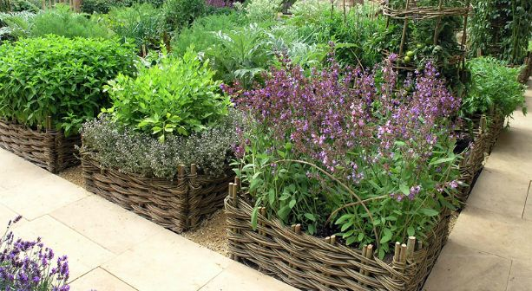
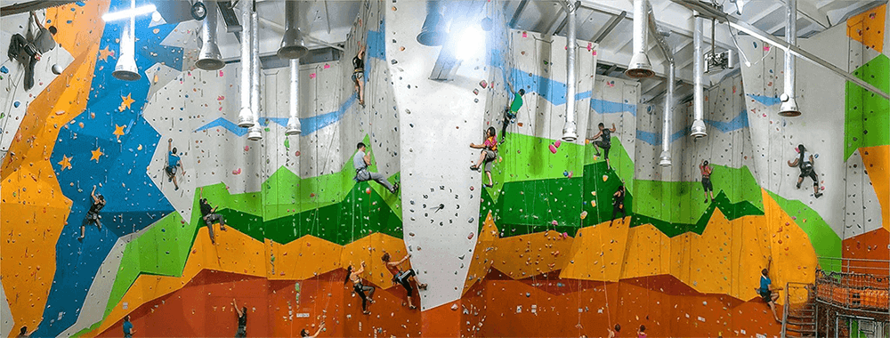
The Dokshitsy rigion
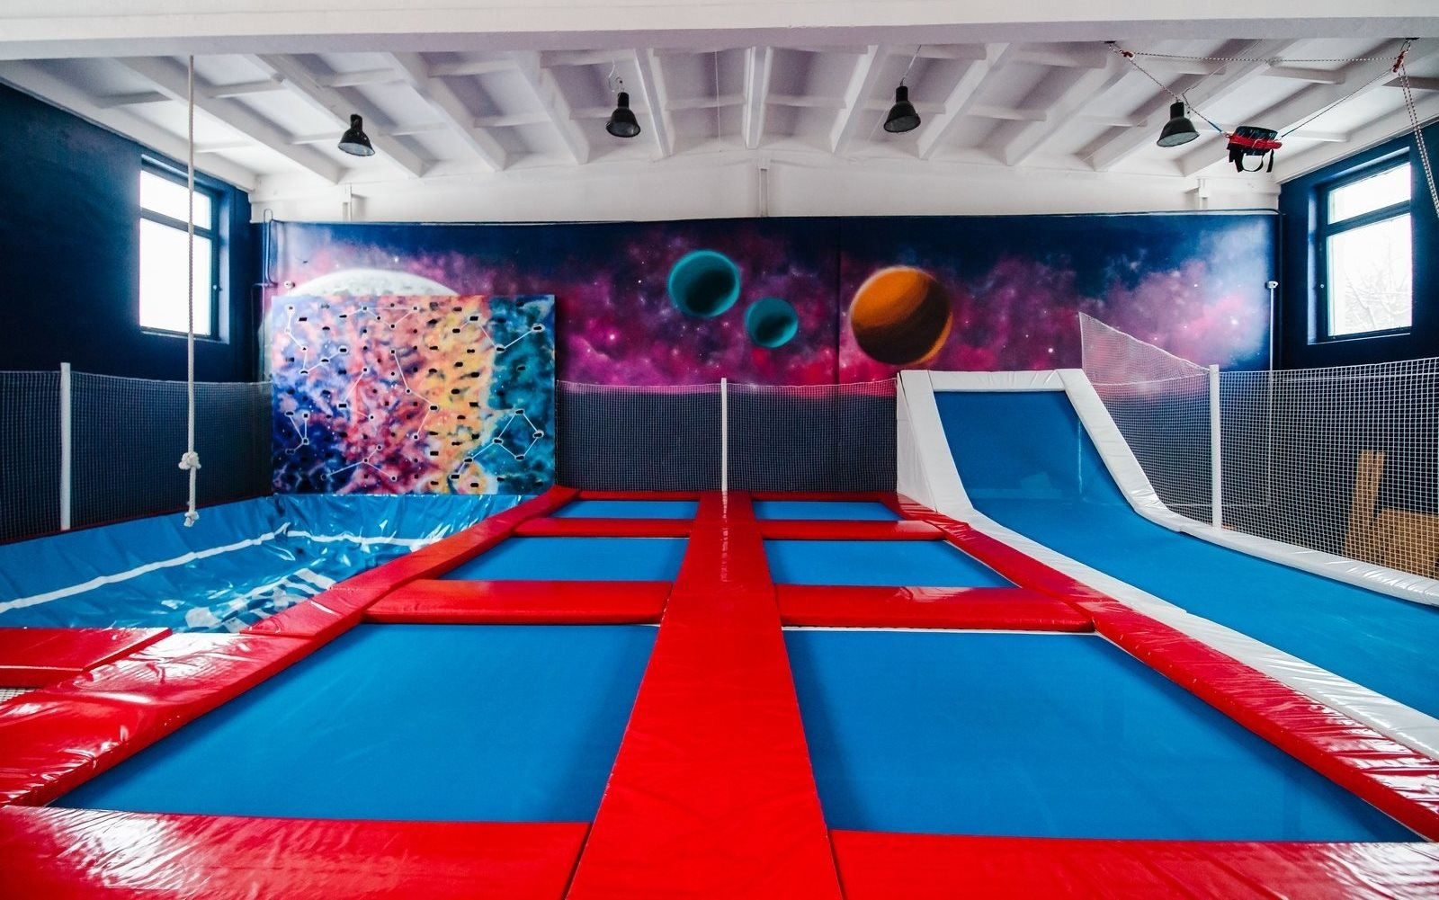
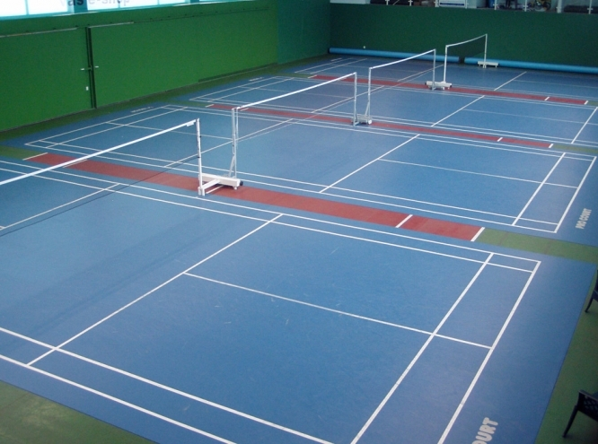

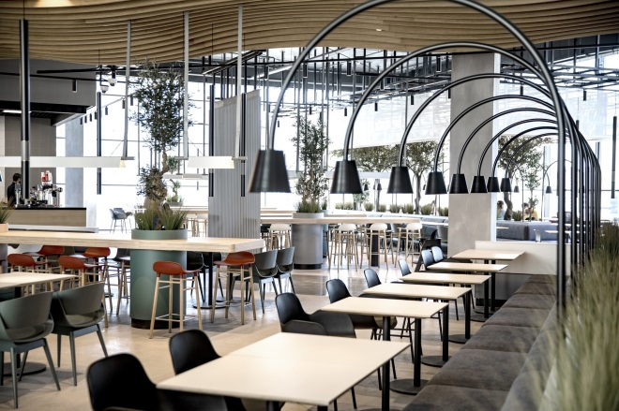
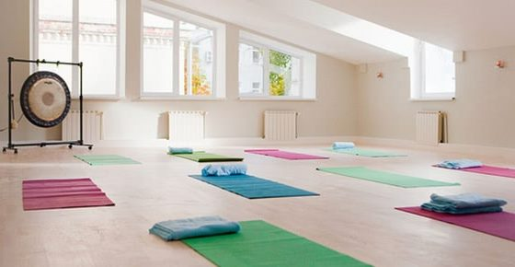
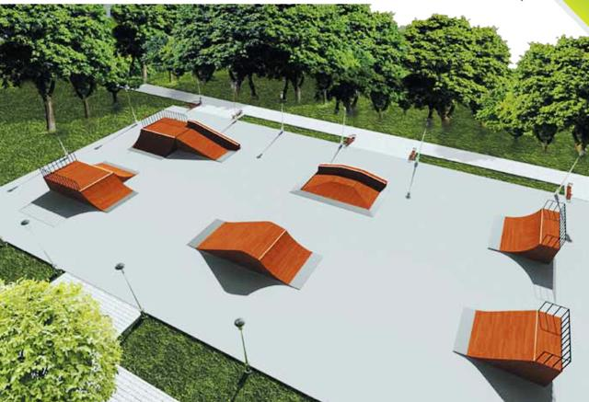

 | Name of the project | Health and development center for children and adults "VITRUVIY»
 | Name of the organization | Sports and tourism sector of Dokshitsy Regional Executive Committee (hereinafter – the sector)
 | Physical and legal address of the organization, phone, fax, e-mail | Vitebsk region, Dokshitsy, Shkolnaya str., 19, 211722, phone/fax 8(02157)2-52-31, fck_dok@mail.ru / doksector@tut.by
 | Information about the organization | The sector was established on June 1, 2018, it is a legal entity which has a structural unit – centralized accounting, it manages sports and tourism in the Dokshitsy region: the development of junior and youth sports and mass physical culture, the training of top-class sportsmen and sports reserves, the development of physical culture and sports movement and health improvement of the region's population. The Sector facilitates the formation and consolidation of sports relations among sports organizations on the territory of the Republic of Belarus and other countries. The sector coordinates the operation of: “Dokshitsy regional junior and youth sports school” and “Dokshitsy regional sports club "Harvest". We have the experience in the relevant project making
 | Head of the organisation | Odintsova Tatyana Nikolayevna, head of the sector, +375333060616 (MTS)
 | Project manager | Rachitskaya Ekaterina Sergeyevna, the inspector of the sector, +375295919989 (MTS)
 | The assistance previously received from other foreign sources | Within the framework of the international technical assistance project "Assistance to local development in the Republic of Belarus", which is funded by the European Union and implemented by the UN development Programme (UNDP) on the territory of the Dokshitsy region, in 2017-2018 “Dokshitsy regional junior and youth school” implemented the local initiative called "Take care of your health since your early days" which resulted in the amount of $29,000
 | Amount required | 1000 000 Euro
 | Co-financing | Regional budget
 | Time-frame | 5 years from the start of the project
 | Project mission | Children and parents health protection, the development of interests, skills, and creative abilities with children and adolescents, popularization of a healthy lifestyle within a family
 | Objectives | 1. To organize healthy leisure and give the opportunity to lead an active life;  2. To involve parents in children’s activities and teach them to cooperate, play, and develop independent skills;  3. To contribute to children's health and reveal their physical potential;  4. To develop children's creative skills and arouse the desire to explore the surrounding world by involving them in various activities
 | The detailed description of the project activities according to the objectives | The creation of a center divided into 5 areas according to their purpose:  Area 1: special interactive playgrounds imitating the work of emergency teams, fire-fighting brigades and police. This area focuses on teaching principles of personal and social safety with children and their parents  Area 2: herbal garden (herbal therapy): growing all kinds of odorous and medicinal herbs for therapy and cooking; mastering practical skills in growing ornamental and medicinal plants  Area 3: sports and recreation area: a climbing wall, a trampoline, a yoga hall, a ballroom, a therapeutic physical training hall, a badminton hall  Area 4: a food court focusing on top-quality, healthy and eco-friendly food. The food court provides a wonderful opportunity for such events as cooking exhibitions, master classes, lectures on healthy nutrition, various targeted festivals, etc.  Area 5: the adjacent territory will be equipped with a cycle track, ramps for skateboarding and roller-skating, a tennis court, and a workout area  An important feature of the center is a barrier-free environment, which makes it available for children with special needs
 | Supporting information | The health and development center for children and adults is one of the most needed projects for the town of Dokshitsy. The number of existing sports and recreation centers is insufficient for meeting physical, intellectual and creative needs of children and adults not only in our region, but also in nearby towns and regions: Dokshitsy (22392 people), Glubokoye (41043 people), Postavy (35969 people), Lepel (32523 people). Not many parents can afford to visit such centers situated far off in bigger provincial cities. All the citizens having children state the necessity of building the center in Dokshitsy for children’s health and all-round development  «VITRUVIY» is a place where children and adults can learn to take care of the environment, cook healthy food, open their minds to the principles of personal and social safety and put their knowledge into practice  «VITRUVIY» is a multi-functional sports complex that meets people’s sports and cultural needs
 | Outcome of the project | Under present circumstances, the health and development center for children and adults "VITRUVIY» will be integrated into a complex network of economic, organizational, legal, social, educational, technical, operational and other types of relationships. As a result, the center can be referred as a complex social object:  -a team of employees who meet people’s physical, intellectual and creative needs through physical education and sports, learning and applying specific knowledge and skills, and participating in various events as spectators;  -an economic entity with a special type of social management that provides day-to-day work and development of sports and recreation facilities and makes available certain services for consumers;  -a specialized unit that offers a wide range of activities
 | Project budget | According to the design estimates

