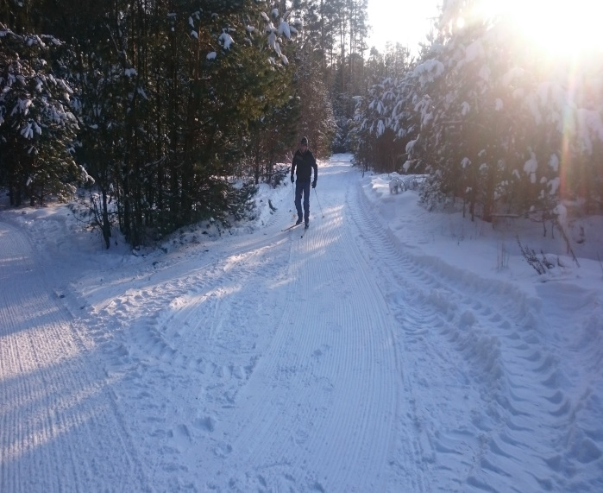 |  |  | 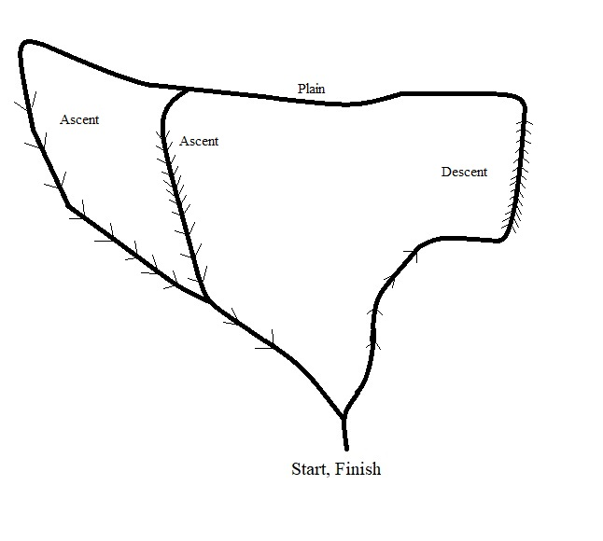
1 | Name of the project | “Healthy path”
2 | Name of the organization | “Dokshitsy regional sports club "Harvest"
3 | Physical and legal address of the organization, phone, fax, e-mail | Vitebsk region, Dokshitsy, Shkolnaya str., 19, phone/fax 8 (02157)55172, fck_dok@mail.ru
4 | Information about the organization | The club was established on July 20, 2007. The main goal of the club is promotion of a healthy life-style, creation of all necessary conditions for the development of physical culture, sports and outdoor activities as well as creating conditions for the sustainable development of tourism
5 | Head of the organization | LobanDmitriySergeyevich, head of the sports club “Harvest” +375293517204
6 | Project manager | LobanDmitriySergeyevich, head of the sports club “Harvest” +375293517204
7 | The assistance previously received from other foreign sources | None
8 | Amountrequired | $219,355
9 | Co-financing | $1,320
10 | Time-frame | 1 year from the start of the project
11 | Project mission | Development of infrastructure and creation of material and technical basis for physical culture and sports
12 | Objectives | 1. Popularization of a healthy lifestyle by involving children and teenagers in sports. Healthy children form a healthy nation!  2. Health improvement of the population of the Dokshitsy region  3. Creating conditions for physical and social rehabilitation of elderly and disabled people as well aspeople with special needs  4. Teachingteenagers and young peoplea tolerant attitude to elderly and disabled people as well as people with special needs
13 | The detailed description of the project activities according to the objectives | Organization ofentertaining events and sports activities in order to promote a healthy life-style. Creation of special interest groups on ski training andnordic walking. Equipment rental
14 | Supporting information | "Healthy path" is located in the intown forest land ofDokshitsy within walking distance, therefore it is available to everyone. "Healthy path" is multipurpose and can be used at any time of the year. Walking in the pine forest or doing physical exercises outdoors is simply necessary for health. The implementation of this project will attract devotees of outdoor activities and nature-lovers to this wonderful nookin the pine forest. Living a healthy life is a background for all-round development of human activities, achieving longevity and performing social duties. The importance of living a healthy life is determined by the increasing pressure on the human body due to the complexity of social life, the growth of anthropogenic, environmental and psychological riskswhich provoke negative changes in humanwell-being
15 | Outcomeoftheproject | “Healthypath” consists of both a track for trainings(500 meters) and a track for competitions(1500 meters). "Healthy path" is multipurpose and suitable for competitions at different levels of complexity. The events arranged on this basis will demonstrate all the positive effects of a healthy life-style to the younger generation.In summerpeople can walk along the path as well as roller-skate, roller-ski, ride a bike or ride ona skateboard. In winter it is possible to take a stroll or use the ski run. All year round people can take up nordic walking. A special interest group on skiing can be organized in Dokshitsy asthe presence of a track allows to be engaged in this activity all year round
16 | Projectbudget | $219,355

