1. Наименование проекта: “Technical creativity is the way of the future! “
2. Срок реализации проекта: 1 year since the launch of the project.
3. Организация – заявитель, предлагающая проект:
State educational institution for further education ” Dokshitsky district centre for children and young people”
4. Цели проекта: Professional self-determination of teenagers through the creation of the club “Junior Tech”.
5. Задачи, планируемые к выполнению в рамках реализации проекта:
- Open and equip the club “Junior Tech”, on which hobby groups such as technical modelling and design, wood treatment, airplane modelling, go-karting, robotics, photography would be based.
- Engage qualified and creative specialists to work with children. Improve the quality and effectiveness of education, strengthen the link between hobby clubs’ activities and practice.
- Involve children and teenagers to participate in the activity of the club “Junior Tech”.
6. Целевая группа: The project is aimed at children and young people who live in Dokshitsy and Dokshitsky district.
7. Краткое описание мероприятий в рамках проекта:
- Establishment period operation of the club for children and teenagers “Junior Tech”.
  - Renovation of the premises where the club activity will be organized.
  - Acquisition of furniture, technical equipment (a milling machine, a lathe and a radial drilling machine; drills, clamp) karts, robotics, components for airplane modelling.
  - Realization of master-classes for children and young people of Dokshitsy and Dokshitsky district.
  - Conducting training and exercises for the club “Junior Tech” trainees.
  - Conducting and participating in district, regional and republican competitions and contests.
- Training course for creative and skilled specialists to work with children.
- Realization of advertising actions for engaging children and teenagers in the club “Junior Tech” activity.
8. Общий объем финансирования (в долларах США): 50000
Источник финансирования | Объем финансирования  (в долларах США)
Средства донора | 45000
Софинансирование | 5000
8. Место реализации проекта (область/район, город): Vitebsk region, Doksthitsy.
9. Контактное лицо:
Svetlana Antonovna Yanukovich, the director of State educational institution for further education ”Dokshitsky district centre for children and young people”, 8-02157-22690, + 37529 3181381, doksh_cdt@mail.ru

State educational institution for further education ” Dokshitsky district centre for children and young people” invites to cooperation co-financing within the humanitarian project “Technical creativity is the way of the future! “
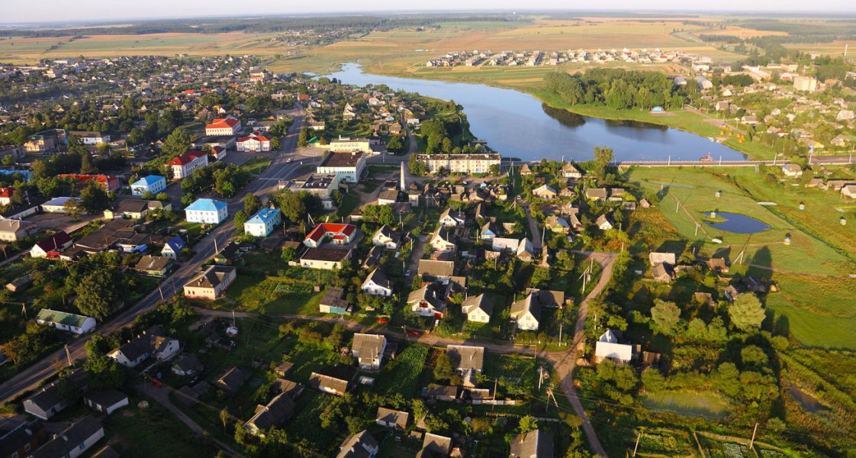

Project title: “Technical creativity is the way of the future! “
Applicant organization, proposing the project: State educational institution for further education ” Dokshitsky district centre for children and young people”
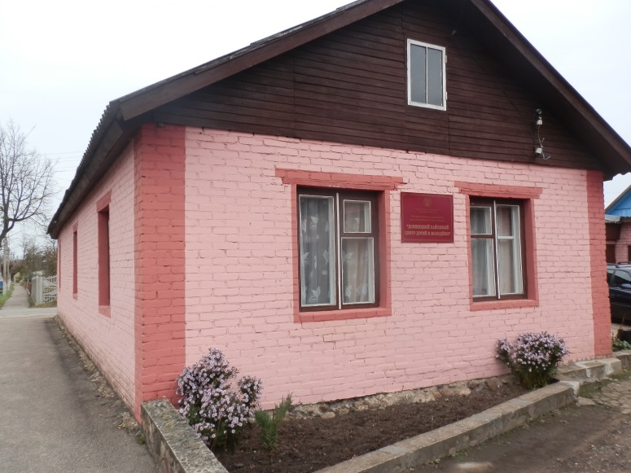
The project aim is to gain knowledge in the field of technical creation by students and provide a guide for children with enabling career choice.
A sociological survey of teenagers from Dokshitsy and Dokshitsky district, which was conducted with the aim of exploring their wishes and requests, showed that teenage boys and many of the teenage girls choose technical hobby clubs. Today there are 9 clubs in our town. Most of the children who were interviewed were reportedly keen on study in groups based on interests such as: technical modelling and design, wood treatment, airplane modelling, go-karting, robotics, photography.
The teenagers have been expressing their wishes for many years. Unfortunately, the institution for further education cannot provide the organization of clubs in all courses because of shortage of classrooms, but mostly, because of lack of necessary equipment and facilities.
The teachers of further education consider that the organization of the club “Junior Tech” will help our town to solve some problems. Firstly, thanks to the club teenagers of our town will spend their leisure time usefully, which leads to juvenile crime reduction. Secondly, interest in machinery can help on the path of developing their own personality and professional capacities. We live in an agricultural district which is in great need of good specialists with technical education.
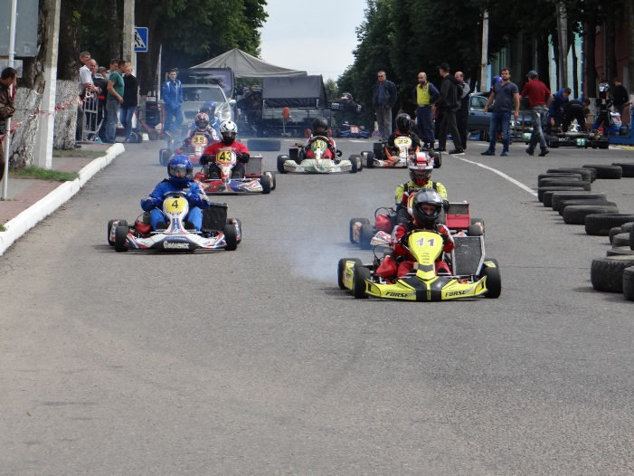
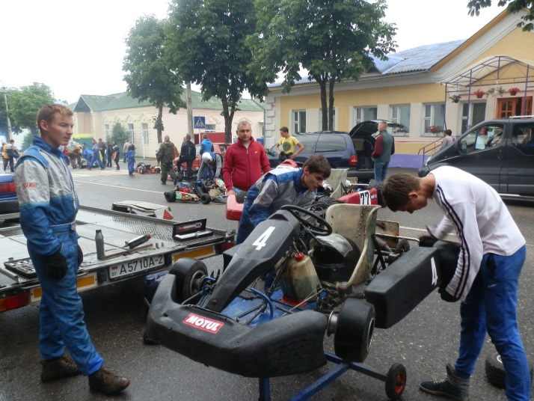
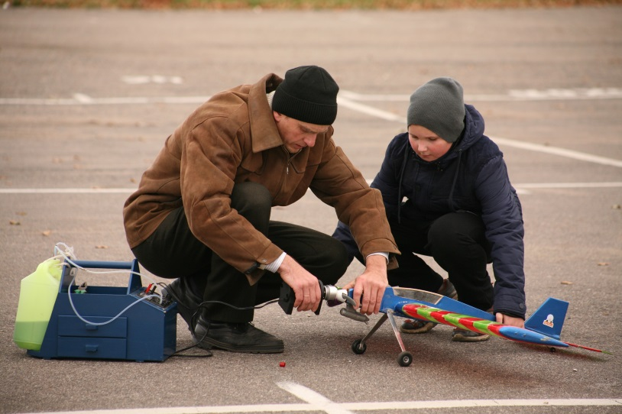
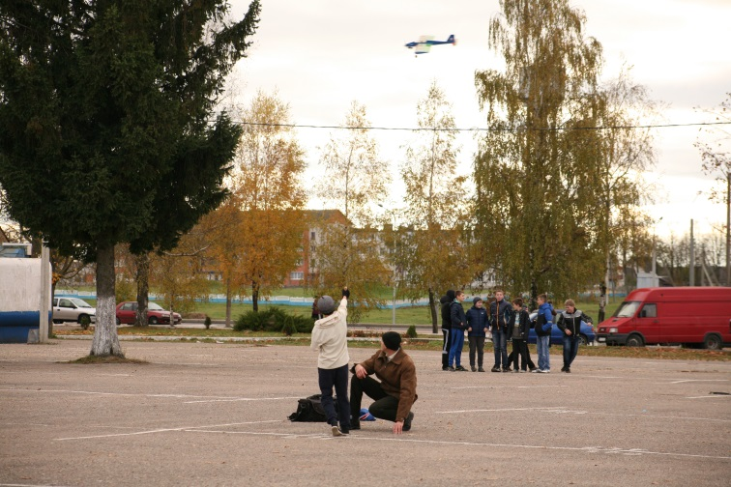

Sphere of activity is considered as the option of future career choice, professional capacity in planning their future life.
The task force: The project is aimed at children and young people who live in Dokshitsy and Dokshitsky district.
The objective of the project: Professional self-determination of teenagers through the creation of the club “Junior Tech”.

Under the project the following tasks are carried out:
- Open and equip the club “Junior Tech”, on which hobby groups such as technical modelling and design, wood treatment, airplane modelling, go-karting, robotics, photography would be based.
- Engage qualified and creative specialists to work with children. Improve the quality and effectiveness of education, strengthen the link between hobby clubs’ activities and practice.
- Involve children and teenagers to participate in the activity of the club “Junior Tech”.
Project duration:1 year since the launch of the project.
Location of the project: Vitebsk region, Doksthitsy.
Total Funding (in US dollars): 50000
Donor funds – 45000
Co-funding – 5000
A summary of the project is contained below.
- Establishment period operation of the club for children and teenagers “Junior Tech”.
  - Renovation of the premises where the club activity will be organized.
  - Acquisition of furniture, technical equipment (a milling machine, a lathe and a radial drilling machine; drills, clamp) karts, robotics, components for airplane modelling.
  - Realization of master-classes for children and young people of Dokshitsy and Dokshitsky district.
  - Conducting training and exercises for the club “Junior Tech” trainees.
  - Conducting and participating in district, regional and republican competitions and contests.
- Training course for creative and skilled specialists to work with children.
- Realization of advertising actions for engaging children and teenagers in the club “Junior Tech” activity.

Realization of the project’s goals and objectives will enhance the interest of students from technical clubs towards careers needed to Dokshitsky district.
The created conditions will help to form a harmoniously developed, socially adapted and mobile personality, with good morals.
Contact person:
Svetlana Antonovna Yanukovich, the director of State educational institution for further education ”Dokshitsky district centre for children and young people”, 8-02157-22690, + 37529 3181381, doksh_cdt@mail.ru

