1. Наименование проекта: "Country of Entertainment"
2. Срок реализации проекта: from August 1, 2019 to August 1, 2020
3. Организация – заявитель, предлагающая проект: The education department of the Dokshitsy district executive committee of Vitebsk region.
4. Цели проекта: the development of a children's camp "Berozka"
5. Задачи, планируемые к выполнению в рамках реализации проекта:
1. Improving the quality of children's health in the summer camp "Berozka";
2. Strengthening the material and technical base of the summer camp "Berozka";
3. Creating a sports ground and a playground at the campsite "Berozka";
4. The introduction of the educational program "Every day holiday";
5. Practical implementation of principles and approaches, analysis and dissemination of the initiative’s experience.
6. Целевая группа:
• Children aged from 6 to 18, including children with the peculiarities of the psychophysical development of Begoml special boarding school of Dokshytsy district; children from substitute families.
• Teachers of Dokshitsy district.
• Parents.
7. Краткое описание мероприятий в рамках проекта:
1. Improving the quality of children's health in the summer recreation camp for children "Berozka"
2. Improvement of the territory and repair of the building
3. Strengthening material and technical base of the catering unit
4. Creation of sports and recreation
sites on the territory of the children's camp " Berozka "
5. Practical implementation of principles and approaches
analysis and dissemination of the initiative’s experience
6. The introduction of the program "Holiday every day"
8. Общий объем финансирования (в долларах США): 40000
Источник финансирования | Объем финансирования  (в долларах США)
Средства донора | 36000
Софинансирование | 4000
8. Место реализации проекта (область/район, город): Vitebsk region, Dokshytsy district, village Vytunichi, summer camp "Berozka".
9. Контактное лицо:
Olga Plygavko, methodologist of the educational and methodical office of the education department of the Dokshitsy district executive committee (802157-59533, reception phone / fax 802157-59541).

Humanitarian project
"Country of Entertainment"

The education department of the Dokshitsy district executive committee of Vitebsk region invites for cooperation and co-financing within the framework of a humanitarian project.

Implementation period:
from August 1, 2019 to August 1, 2020

2018
Introduction

Summer is a bright and unforgettable time of school holidays, when children discover the world and look for themselves in this world, experience summer nature, get positive emotions, useful and entertaining information voluntarily and always with pleasure.
The summer health promotion campaign is an important part of the educational activities aimed at the forming of a child's personality.
A large summer break is given to schoolchildren to strengthen their health, physical conditioning, to acquire dexterity and courage. This time is also spiritual enrichment, vivid impressions, creativity and active cognition of something new.
Summer period is an active time for the socialization of schoolchildren.
A significant extension of the field of interaction gives new additional opportunities for the personal growth of each child and his self-improvement. Therefore, it is necessary to create appropriate pedagogical conditions to provide useful, meaningful employment for children, contributing to the development of positive qualities of their personality during the summer holidays in a summer camp shift using a variety of forms of activity and communication during the summer holidays.
The content of a shift in the recreation 24-hour camp "Berezka" includes the involvement of children in various activities, improving communication skills, collective and individual forms of activities, a variety of socially important roles and positions of the participants of the shift.
Our camp gives children the opportunity to be engaged in creative activities, to gain personal experience, to diversify leisure in the company of like-minded people.
The main thing in the work of the camp is physical, moral and psychological recovery of children, as well as practical consolidation of knowledge and skills in certain types of creativity.
For better organization of children's rehabilitation, we need to solve the basic tasks: to strengthen the material and technical base, to develop physical culture and sports activities, to improve the camp area and educational work within the framework of the project “Every day holiday”.
The object of the implementation of the tasks are children who are under special control and who require increased attention from the executive branch and teaching staff. These are children with the status of orphans, or children with peculiar psychophysical development, children in custody.
It is our fundamental task to give them the opportunity to feel attention, care, get good nutrition, as well as to spend the summer holidays diversifying their various interesting activities, participation in gaming programs, competitions, holidays, concerts, sports.
This project draws attention first of all to the formation of an inclusive culture in the educational and recreational educational institution “Berezka”, focused on the development of such personal qualities as a tolerant attitude to the disabled and to the children with peculiar psychophysical development, charity etc.

Brief description of the recreational camp "Berozka"

The children's recreational camp “Berozka” of Dokshitsy district in Vitebsk region is an educational and wellness institution for children aged 7 to 18.
Recreational camp "Berozka" is for children with peculiar psychophysical development, orphans, children of Begoml special boarding school of Dokshitsy district.
The recreation of children and their recovery consists of a set of activities that promote the development of children's creative potential, protect their health, prevent children from diseases, engage in physical activities, sports and tourism, develop children’s skills of a healthy lifestyle and healthy diet in accordance with hygienic and sanitary-epidemiological requirements.
The territory of the camp is located near the forest where deciduous and coniferous trees dominate.
The staff is 54 people.
Living conditions: children live in a brick two-storey building (with cold and hot water, sewage, heating, a drying room, a hygienic room for girls, bathrooms on each floor, showers, etc.).
The year of construction - 1984.
The occupancy of the bedrooms: 7-8 (beds with bedding sets, a wardrobe, mirrors, bedside tables, carpets). Children are placed by age, boys and girls live separately. Children's bedrooms are combined with the rooms of camp counselors.

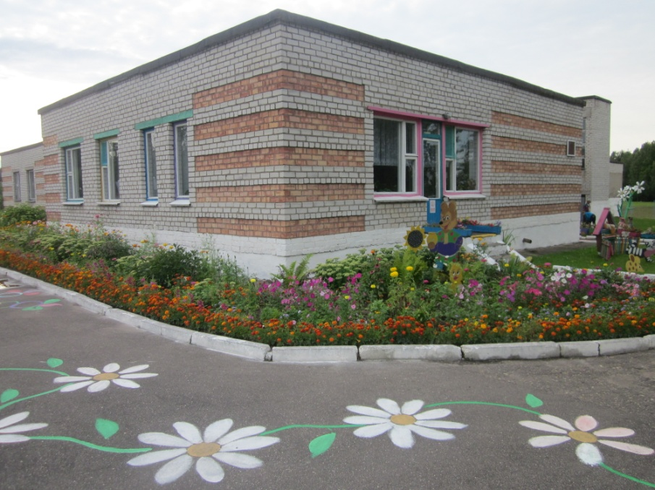

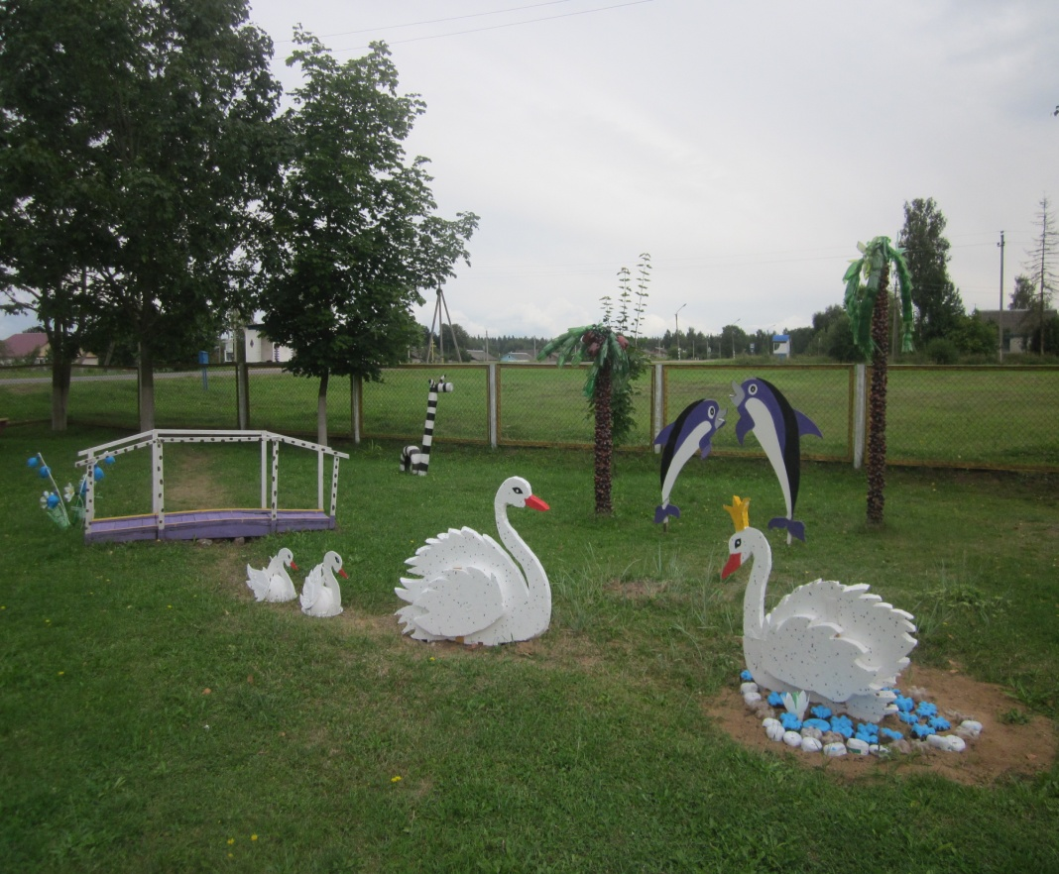

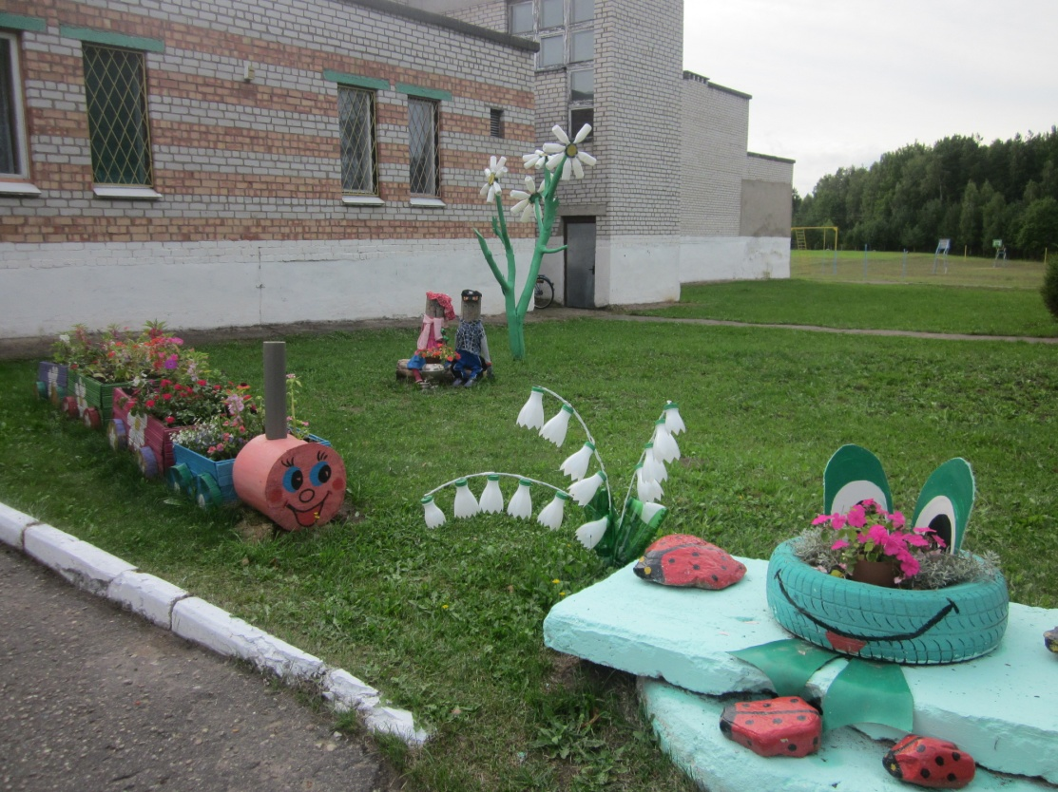

The purpose of the project: the development of a children's camp "Berozka"
Tasks:
1. Improving the quality of children's health in the summer camp "Berozka";
2. Strengthening the material and technical base of the summer camp "Berozka";
3. Creating a sports ground and a playground at the campsite "Berozka";
4. The introduction of the educational program "Every day holiday";
5. Practical implementation of principles and approaches, analysis and dissemination of the initiative’s experience.

Target group:
• Children aged from 6 to 18, including children with the peculiarities of the psychophysical development of Begoml special boarding school of Dokshytsy district; children from substitute families.
• Teachers of Dokshitsy district.
• Parents.

Plan of activities within the project:

Task № 1. Improving the quality of children's health in the summer recreation camp for children "Berozka"

№ | Event | Period of execution | Number of participants
 | Training seminars for teachers "Sports and recreational work in a children's camp" | May,  2019 | 20
 | Opening clubs of interest aimed at developing culture of healthy lifestyle among children: « Checkers and Chess »  «Outdoor games»  «Mini football»  «Football», «Volleyball», « Table tennis ». | June - August 2019 | from 12 to 15
 | Survey for teachers and children "The level of awareness about the culture of a healthy lifestyle" | at the beginning and at the end of 1,2,3 camp shifts | 240
 | Vitaminization of the diet of children | June – August 2019 | 240
 | Informing about the project and its activities on the website of the Education Department of Dokshytsy District, the regional newspaper “Rodnyya Vytoki” | June – August 2019

Task №2. Improvement of the territory and repair of the building

№ | activity | quantity
1. | Laying asphalt concrete pavement with the installation of borders | 500м² asphalt  150м/p border
2. | Replacement of the fencing of the area (replacement of the fence, exit gate) | fence -200м/p  exit gate -2
3. | Landscaping (garden houses for recreation, the creation of small architectural forms) | 2 garden houses, 4 benches
4. | Construction of a canopy at the main entrance | 1 canopy
5. | Renewal of the central porch with tiling | 20m³- concrete  100m²-tiles
6. | Replacing windows by double glazed windows | 50 double glazed windows
7. | Purchase of chairs for the music room | 100 pcs
8. | Replacing lamps | 300 pcs
9. | Foyer equipment (purchase of furniture: soft corner, stools)
10. | Replacing doors in bedrooms and utility rooms | 30 pcs
11. | Replacement of furniture in the dining room (dining tables, chairs) | 50 dining tables,50 chairs
12. | Partial repair of electrical wiring and sewage | electrical wiring 350м/p  wiring -150м/p
13. | Repair of showers (replacement of tiles on the walls and floor) | 2
14. | Rebuilding of a spare porch with tile laying | concrete -10m³  tiles -70m²

Task №3. Strengthening material and technical base of the catering unit

№ п/п | Мероприятия | quantity
1. | Buying: a combi-steamer with containers, a stand, a filter, a stove hood;  a dishwasher;  a refrigerator;  a vegetable cutting machine;  kitchen tables; | 1  1  1  1  3

Task №4. Creation of sports and recreation
sites on the territory of the children's camp " Berozka "

№ | Activity | quantity
1. | Arrangement of a children's playground | children's slide,  sandbox  swing  merry-go-round
2. | Sports shot replacement | (horizontal bar, football goal, basketball hoops (2pcs), volleyball net stands, rubber mats for a running track, football goal net (2 pcs.), volleyball net (1 pc.), a pit for jumps, throwing sector)
3. | Arrangement of a mini-site with artificial covering | 1 mini-site
4. | Buying sports equipment | a football - 5 pcs.  a basketball - 5 pcs.  a volleyball - 5 pcs.  gymnastic sticks - 5 pcs.  hoops - 5 pcs.
5. | Buying a tennis table | 1 pc.
6. | Arrangement of the site for workout | (simulators, slide, crossbars, gymnastic ladder, logs, labyrinths, etc.)

Task №5. Practical implementation of principles and approaches
analysis and dissemination of the initiative’s experience
№ | Activity | period of execution
1. | Creation of methodological materials on work experience in summer camp " Berozka " and implementation of the initiative | September 2020
2. | Organizing a final workshop for partners and interested teachers to propagate and share experiences | August 2020
3. | The introduction of the experience gained in the organization and conduct of subsequent shifts of the recreation camp " Berozka " | constantly
4. | Getting ready to report on the initiative | constantly

Task №6. The introduction of the program "Holiday every day"

The idea of creating conditions for joint recreation, communication, activities, implementation of the initiative of adolescents through the organization of thematic days, events, creative competitions, sports competitions, games, etc., is the basis of the “Every Day Holiday” education program.

Tasks of the program:
- to activate the creative potential, the initiative of the pupils;
- to include pupils in various types of socially significant activities, to acquaint with the forms and ways of organizing leisure activities, to teach them to organize their own leisure and leisure of others;
- to form the skills of a healthy lifestyle;
- use the rich natural and climatic factor as a way to organize and ensure the process of recovery of pupils.

Expected results:
• self-realization, self-organization, self-assertion, self-improvement of pupils;
• application of acquired knowledge in everyday life;
• health improvement of pupils, improvement of their physical and moral state.

Approximate plan of the camp
Day | Events
Day 1 | “Hello, camp!” (Presentation of the camp “Berozka”, a camp tour, playground “Let’s get acquainted”)
Day 2 | “Children's Holiday” (sports competition “Bag Fun”, creative task “Dreams of our childhood”)
Day 3 | The unusual holiday of acting skills
Day 4 | Holiday of songs
Day 5 | Holiday of dances
Day 6 | Holiday "Day of Nature"
Day 7 | Quest journey in search of treasure
Day 8 | Holiday "Around the World in 45 minutes"
Day 9 | “Holiday of tourism” (game “Tourist mix”, contest of tourist song)
Day 10 | Glamor party (game "Glamour bow", fashion contest "Glamour-party")
Day 11 | Sports and entertainment programme "Dexterous, strong, skillful"
Day 12 | Avant-garde fashion contest "Summer Fun"
Day 13 | Holiday "Love and kindness"
Day 14 | Holiday «Friendship»
Day 15 | The Neptune Festival
Day 16 | The Fair of Guinness Records
Day 17 | Holiday "Belorusiada"
Day 18 | Closing of the camp shift. Holiday "Magic of Summer" (Operation "Cosiness", "Suitcase", walk "Farewell")

Total funding (in US dollars): 20,000.
Source of financing: amount of financing (in US dollars)
• donor funds (in US dollars): 18000
• co-financing (in US dollars): 2000
Location of the project: Vitebsk region, Dokshytsy district, village Vytunichi, summer camp "Berozka".
Contact person: Olga Plygavko, methodologist of the educational and methodical office of the education department of the Dokshitsy district executive committee (802157-59533, reception phone / fax 802157-59541).

